Nuclear Medicine Imaging Techniques
The following techniques are used in the diagnosis, management, treatment, and prevention of disease. Nuclear medicine is unique in that it often allows for diagnostic information to be discerned prior to the onset of physical symptoms.
Planar
Provides a two-dimensional view of the process or function of the organ being imaged.
SPECT
(Single Photon Emission Computed Tomography)
Provides 3-D computer-reconstructed images of multiple views and function of the organ being imaged.
PET
(Positron Emission Tomography)
Produces high energy, 3-D computer-reconstructed images measuring and determining the function or physiology in a specific organ, tumor, or other metabolically active site.

Nuclear Medicine Scan
The images produced as the result of a nuclear medicine procedure, often referred to as the actual procedure, examination or test.
Radiopharmaceutical
Also referred to as tracer or radionuclide. The basic radioactively tagged compound necessary to produce a nuclear medicine image.
Gamma Camera
The basic instrument used to produce a nuclear medicine image.
In Vitro
In vitro procedures are done in test tubes. Radioimmunoassay (RIA) is a special type of in vitro procedure that combines the use of radiochemicals and antibodies to measure the levels of hormones, vitamins, and drugs in a patient's blood.
In Vivo
In vivo procedures are when trace amounts of radiopharmaceuticals are given directly to a patient. The majority of nuclear medicine procedures are in vivo.

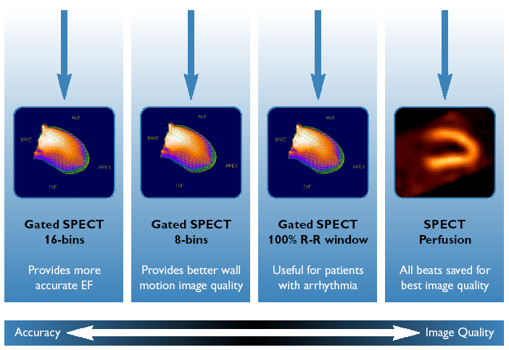

Radiofarmaconok - 2 -
